Library Management System

Code:

#include<iostream>

#include<fstream>

#include<iomanip>

#include<stack>

#include<windows.h>

using namespace std;

class book

{

public:

string title;

string author;

int ISBN;// 4 digit international standard book number

int num;// number of copies

book()

{

title = "";

author = "";

ISBN = 0;

num = 0;

}

};

class node

{

public:

book data;

node\* next;

node()

{

next = NULL;

}

};

class library

{

node\* head;

public:

library()

{

head = NULL;

ifstream fin("Text.txt");

node\* temp = new node;

while (!fin.eof())

{

if (!fin.eof())

{

temp = new node;

fin >> temp->data.title;

fin >> temp->data.author;

fin >> temp->data.ISBN;

fin >> temp->data.num;

temp->next = NULL;

if (head == NULL && !fin.eof())

{

head = temp;

}

else if(!fin.eof())

{

node\* move = new node;

move =head;

while (move->next != NULL)

{

move = move->next;

}

move->next = temp;

}

}

}

fin.close();

}

void insert(book &obj)

{

node\* temp = new node;

temp->data.author = obj.author;

temp->data.title = obj.title;

temp->data.ISBN = obj.ISBN;

temp->data.num = obj.num;

temp->next = NULL;

node\* move = head;

while (move->next != NULL)

{

move = move->next;

}

move->next = temp;

cout << "Inserted Succesfully" << endl;

}

void search()

{

char x=' ';

int y = 0;

cout << "Are you from management? [Y/N]" << endl;

cin >> x;

if (x == 'Y')

{

cout << "Enter the password " << endl;

cin >> y;

if (y == 1234)

{

cout << "Authorized" << endl;

}

else

{

cout << "Wrong Access" << endl;

}

}

string z = "";

cout << "Enter the Search" << endl;

cin >> z;

int count = 0;

node\* search = head;

bool flag = 0;

stack<book> st;

while(search)

{

count = 0;

string str1 = search->data.author;

string str2 = search->data.title;

int str3 = search->data.ISBN;

for (int i = 0; i < z.length(); i++)

{

flag = 0;

for (int j = 0; j < str1.length(); j++)

{

if (str1[j] == z[i])

{

count++;

flag = 1;

break;

}

}

if (flag == 0)

{

for (int j = 0; j < str2.length(); j++)

{

if (str2[j] == z[i])

{

count++;

flag = 1;

break;

}

}

}

if (flag == 0)

{

int temp = 0;

int cpy = str3;

while (cpy != 0)

{

temp = cpy % 10;

cpy /= 10;

if (z[i] - 48 == temp)

{

count++;

flag = 1;

break;

}

}

}

}

if (count >= z.length())

{

st.push(search->data);

}

search = search->next;

}

if (st.empty())

{

cout << "No Related Book Available" << endl;

}

else if (y != 1234)

{

system("cls");

cout << "\n\n\n\n\n\n\n\n" << endl;

cout << setw(70) << "Library Management System" << endl;

cout << setw(70) << "-------------------------" << endl;

cout << "\n\n\n" << endl;

cout << "|------------------------------|" << endl;

cout << "|" << setw(10) << "Title" << setw(6) << "|" << setw(10) << "Author" << setw(5) << "|"<< endl;

while (!st.empty())

{

book temp = st.top();

st.pop();

cout << "|" << setw(12) << temp.title << setw(4) << "|" << setw(12) << temp.author << setw(3) << "|" << endl;

}

cout << "|------------------------------|" << endl;

}

else if(y==1234)

{

system("cls");

cout << "\n\n\n\n\n\n\n\n" << endl;

cout << setw(70) << "Library Management System" << endl;

cout << setw(70) << "-------------------------" << endl;

cout << "\n\n\n" << endl;

cout << "|---------------------------------------------------------------------|" << endl;

cout << "|" << setw(10) << "Title" << setw(6) << "|" << setw(10) << "Author" << setw(5) << "|" << setw(10) << "ISBN" << setw(8) << "|" << setw(10) << "Copies" << setw(11) << "|"<<endl;

while (!st.empty())

{

book temp = st.top();

st.pop();

cout << "|" << setw(12) << temp.title << setw(4) << "|" << setw(12) << temp.author << setw(3) << "|" << setw(10) << temp.ISBN << setw(8) << "|" << setw(11) << temp.num << setw(10) << "|" << endl;

}

cout << "|---------------------------------------------------------------------|" << endl;

cout<<"\n\n" << endl;

}

int f = 0;

cout << "Press any integer to continue...." << endl;

while (!(cin >> f))

{

cout << "Enter number" << endl;

cin.clear();

cin.ignore(123, '\n');

}

}

void modify()

{

cout << "The title of the books are" << endl;

node\* temp = head;

int check = 1;

while (temp != NULL)

{

cout <<check<<". " <<temp->data.title << endl;

check++;

temp = temp->next;

}

int a = 0;

cout << "Which book you want to update" << endl;

cin >> a;

temp = head;

for (int i = 0; i < a-1; i++)

{

temp = temp->next;

}

cout<<"The book selected is :"<<temp->data.title << endl;

char x = ' ';

int y = 0;

cout << "Are you from management? [Y/N]" << endl;

cin >> x;

if (x == 'Y')

{

cout << "Enter the password " << endl;

cin >> y;

if (y == 1234)

{

cout << "Authorized" << endl;

}

else

{

cout << "Wrong Access not able to modify" << endl;

cout << "Please Wait" << endl;

}

}

else if (x == 'N')

{

cout << "Not able to Modify Thankyou" << endl;

cout << "Please Wait" << endl;

}

if (y == 1234)

{

int s = 0;

cout << "Press 1 to change title" << endl;

cout << "Press 2 to change author name " << endl;

cout << "Press 3 to change ISBN number" << endl;

cout << "Press 4 to change number of books available in library " << endl;

cin >> s;

if (s == 1)

{

cout << "Enter the new title" << endl;

cin >> temp->data.title;

cout << "Please Wait" << endl;

}

else if (s == 2)

{

cout << "Enter the new author's name" << endl;

cin >> temp->data.author;

cout << "Please Wait" << endl;

}

else if (s == 3)

{

cout << "Enter new 4 digit ISBN number " << endl;

cin >> temp->data.ISBN;

cout << "Please Wait" << endl;

}

else if (s == 4)

{

cout << "Enter the copies available of this book in libraray" << endl;

cin >> temp->data.num;

cout << "Please Wait" << endl;

}

}

Sleep(3000);

}

void remove()

{

char x = ' ';

int y = 0;

cout << "Are you from management? [Y/N]" << endl;

cin >> x;

if (x == 'Y')

{

cout << "Enter the password " << endl;

cin >> y;

if (y == 1234)

{

cout << "Authorized" << endl;

}

else

{

cout << "Wrong Access not able to DEL" << endl;

}

}

else if (x == 'N')

{

cout << "Not able to Modify Thankyou" << endl;

}

if (y == 1234)

{

cout << "The title of the books are" << endl;

node\* temp = head;

int check = 1;

while (temp != NULL)

{

cout << check << ". " << temp->data.title << endl;

check++;

temp = temp->next;

}

int a = 0;

cout << "Which book you want to delete" << endl;

cin >> a;

temp = head;

for (int i = 0; i < a-2; i++)

{

temp = temp->next;

}

char ent;

node\* del = temp->next;

cout << "The book selected is :" << del->data.title << endl;

cout << "Are you sure to delete[Y/N]" << endl;

cin >>ent;

if (ent == 'Y')

{

temp->next = del->next;

delete del;

del = NULL;

cout << "Deleted" << endl;

}

}

Sleep(3000);

}

~library()

{

ofstream fout("Text.txt");

node\* temp = head;

while (temp != NULL)

{

fout << temp->data.title << " " << temp->data.author << " " << temp->data.ISBN << " " << temp->data.num<<endl;

temp = temp->next;

}

fout.close();

}

};

int main()

{

cout << "\n\n\n\n\n\n\n\n" << endl;

cout << setw(70) << "Mini Library Management System" << endl;

cout << setw(70) << "------------------------------" << endl;

Sleep(3000);

system("cls");

cout << "\n\n\n\n\n\n\n\n" << endl;

cout << setw(70)<< "Loading Data From File" << endl;

cout << setw(70) << "----------------------"<< endl;

Sleep(3000);

system("cls");

library l1;

int a=1;

while (a != 0)

{

system("cls");

cout << "Press 1 to add a new book " << endl;

cout << "Press 2 to search a book " << endl;

cout << "Press 3 to modify a book " << endl;

cout << "Press 4 to delete a book " << endl;

cout << "Press 0 to exit" << endl;

while(!(cin >> a))

{

cout << "Enter number" << endl;

cin.clear();

cin.ignore(123, '\n');

}

if (a == 1)

{

book o;

cout << "Enter the data required for book :" << endl;

cout << " Title : ";

cin >> o.title;

cout << endl;

cout << " Author Name : ";

cin >> o.author;

cout << endl;

cout << " ISBN(4 Digit Longer) : ";

cin >> o.ISBN;

cout << endl;

cout << " Number of Copies : ";

cin >> o.num;

cout << endl;

l1.insert(o);

cout << "Added Successfully" << endl;

}

else if (a == 2)

{

l1.search();

}

else if (a == 3)

{

l1.modify();

}

else if (a == 4)

{

l1.remove();

}

else if(a>4)

{

cout << "Wrong Selection" << endl;

}

}

cout << "Program Ends Thankyou" << endl;

}

Output

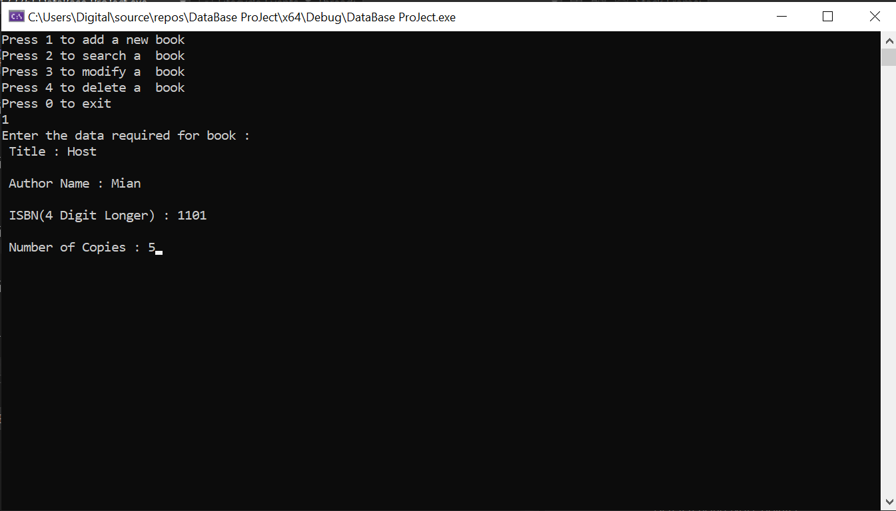

o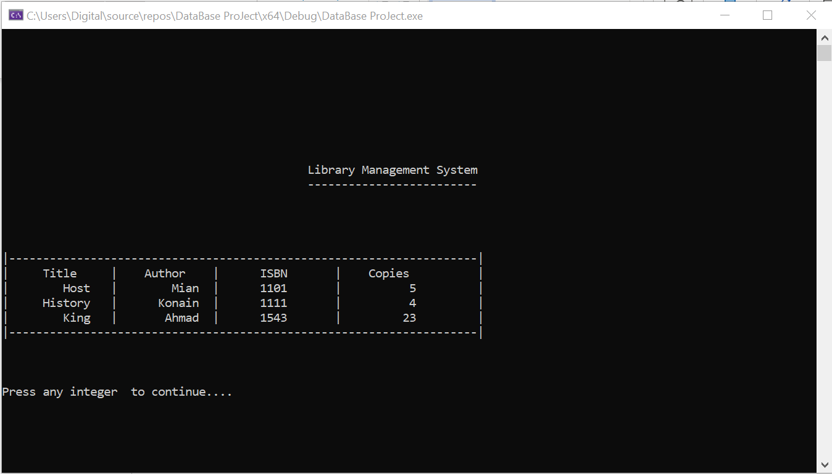

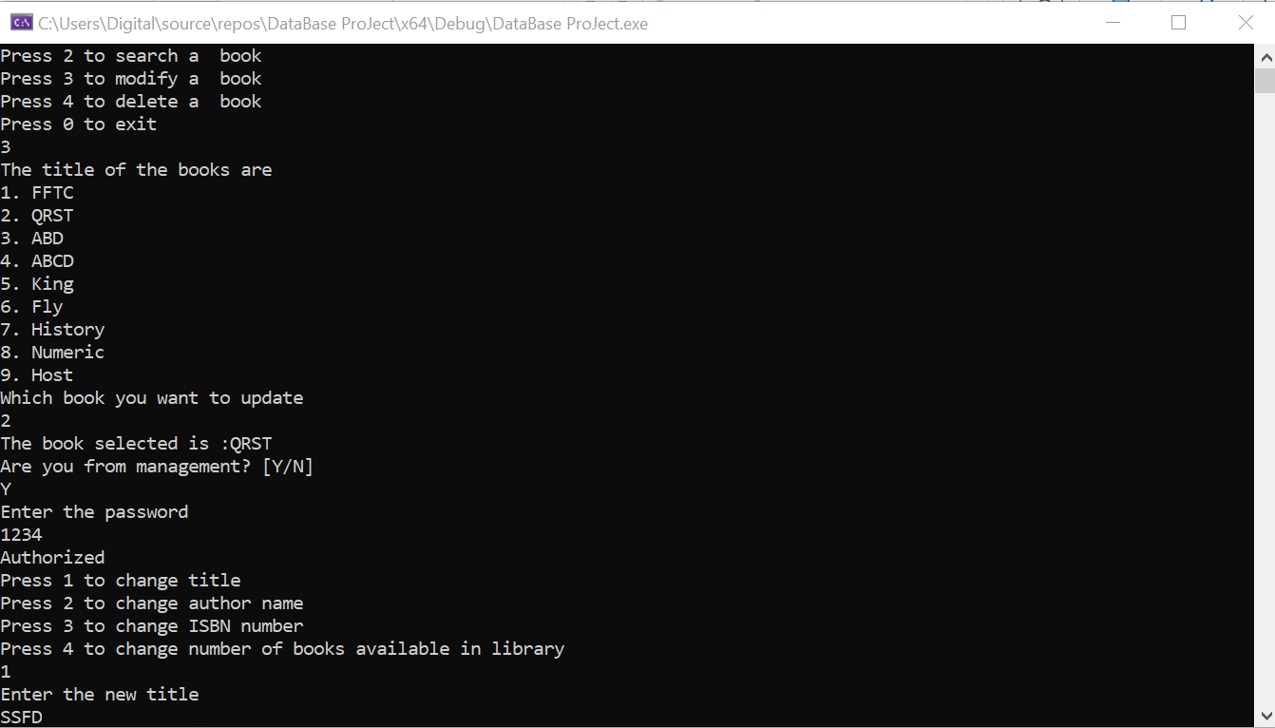

Last Book Deleted

